**PHASE II – FINAL ASSESMENT**

**FLY AWAY**

**Rajagopal Sai Krishna**

**2499086**

**Outputs:**

**Admin Login:**

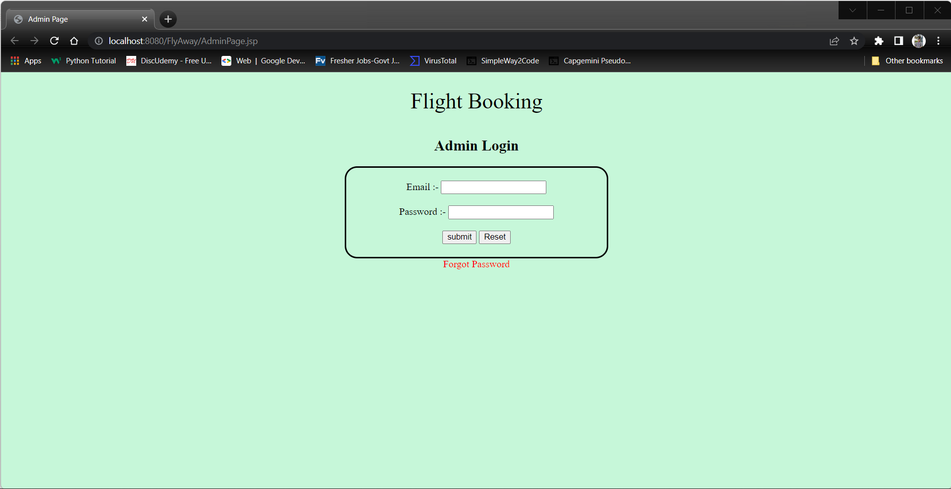

**Admin Home:**

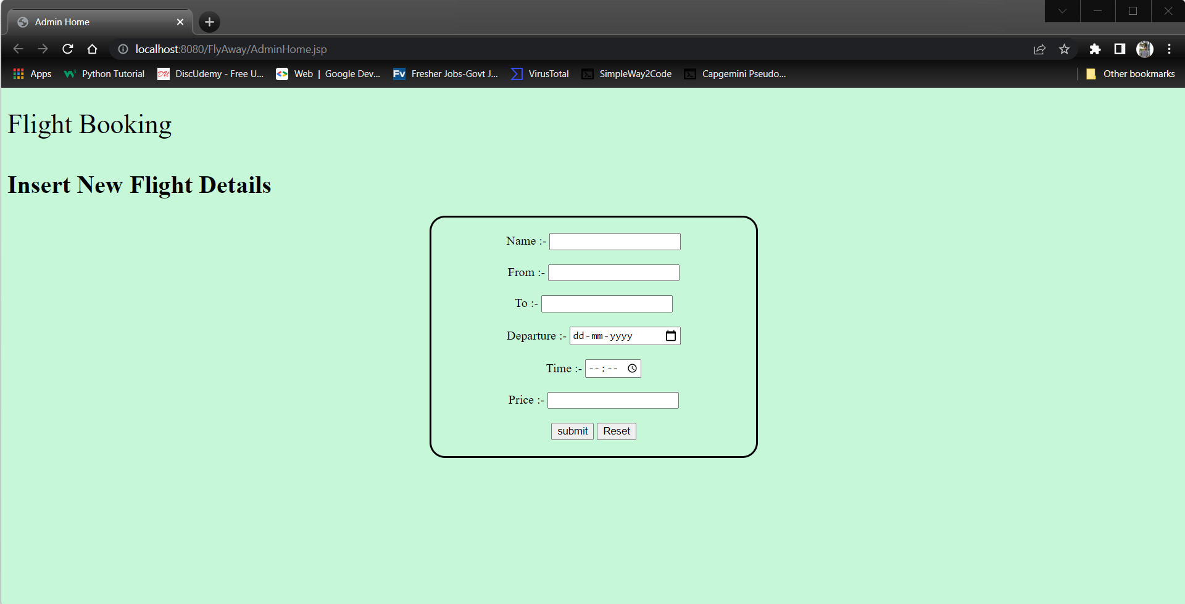

**User Login:**

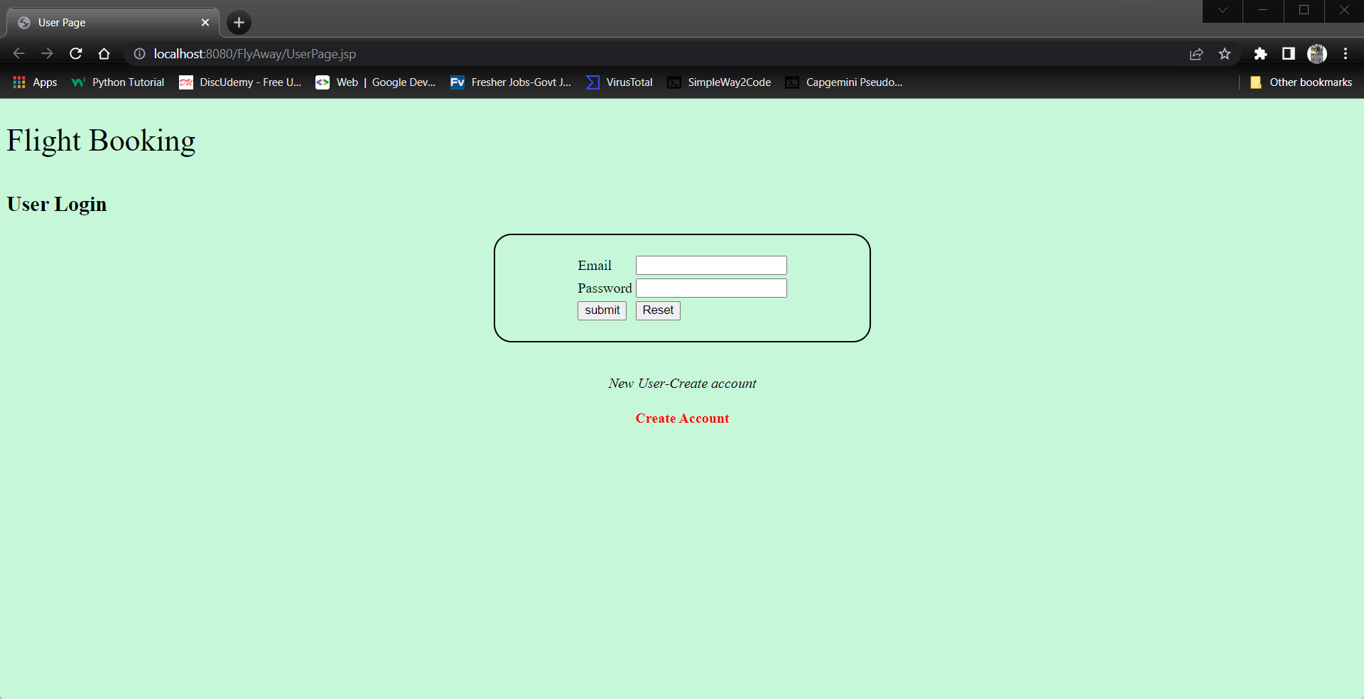

**User Registration:**

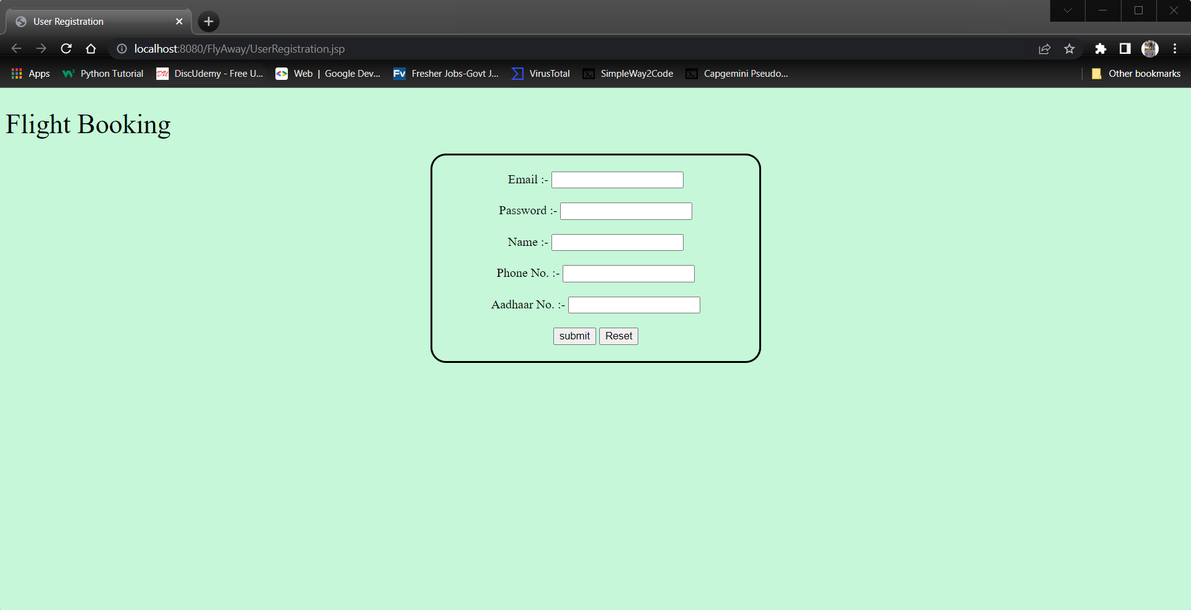

**Password Reset:**

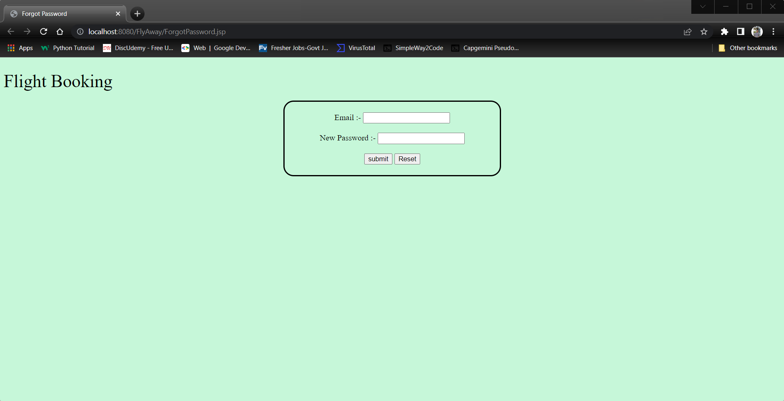

**Flight Booking:**

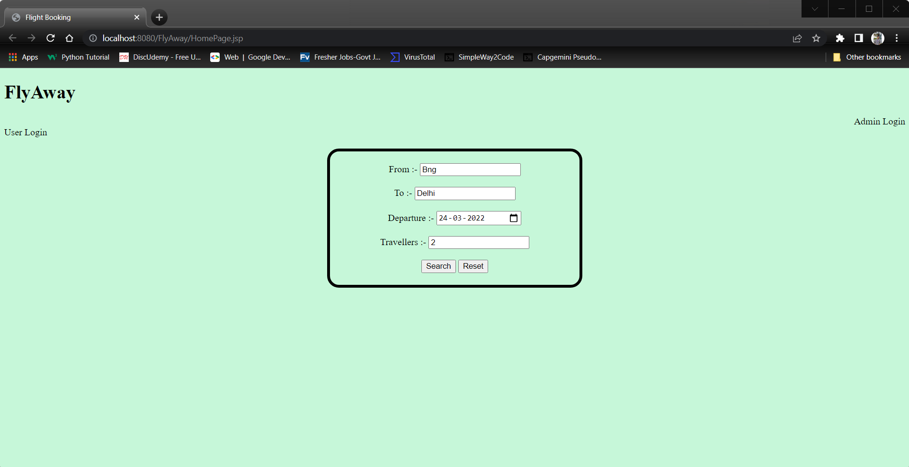

**Flight List:**

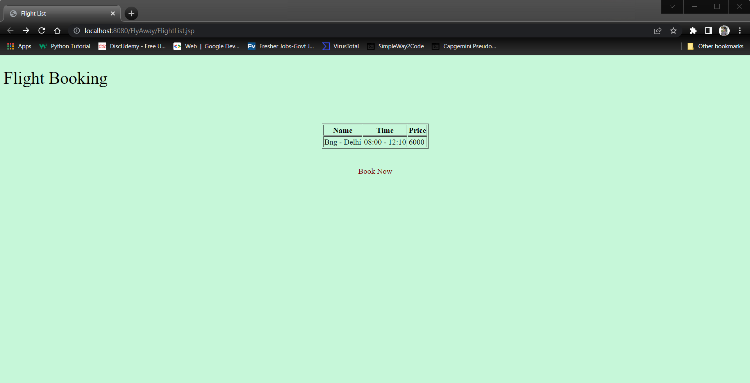

**Booking Successful::**

